Ex.No:6: GENERATION AND ANALYSIS OF FREQUENCY MODULATED (FM) AND OF PHASE MODULATED (PM) SIGNALS USING MATLAB
Objective 1:
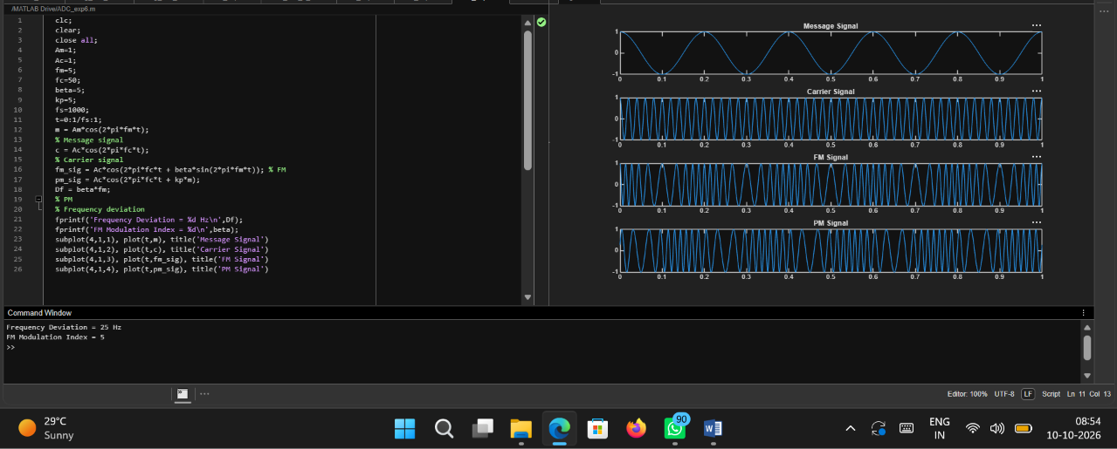
Code:
clc;
clear;
close all;
Am=1;
Ac=1;
fm=5;
fc=50;
beta=5;
kp=5;
fs=1000;
t=0:1/fs:1;
m = Am*cos(2*pi*fm*t);
% Message signal
c = Ac*cos(2*pi*fc*t);
% Carrier signal
fm_sig = Ac*cos(2*pi*fc*t + beta*sin(2*pi*fm*t)); % FM
pm_sig = Ac*cos(2*pi*fc*t + kp*m);
Df = beta*fm;
% PM
% Frequency deviation
fprintf('Frequency Deviation = %d Hz\n',Df);
fprintf('FM Modulation Index = %d\n',beta);
subplot(4,1,1), plot(t,m), title('Message Signal')
subplot(4,1,2), plot(t,c), title('Carrier Signal')
subplot(4,1,3), plot(t,fm_sig), title('FM Signal')
subplot(4,1,4), plot(t,pm_sig), title('PM Signal')

Output:
